CAPSTONE FINAL REPORT
Forecasting Daily Retail Demand from Weather, Holiday, and Calendar Signals
Prepared for: Retail Client — Store Operations & Inventory Planning
Prepared by: Data Science Capstone Team
August 2026

Executive Summary
This project builds a daily demand-forecasting model for a multi-store, multi-category retail operation. The goal is to predict units sold per store/category/day from calendar, weather, holiday, promotion, and recent-sales signals, so that inventory and staffing decisions can be made from a forecast rather than gut feel or a simple "same as last week" rule.
Three modeling approaches were built and tuned with time-series-aware cross-validation (regularized linear regression, a random forest, and gradient-boosted trees), then compared against a naive seasonal baseline on a chronologically held-out 90-day test period. All three tuned models beat the baseline by a wide margin. The best-performing model was a tuned Random Forest Regressor, which reduced forecast error (RMSE) by 63% versus the naive baseline and explains about 97% of the variance in daily sales on unseen test data.
The strongest predictors of daily sales are a store/category's own recent sales history (a 28-day rolling average dominates), followed by whether an item is on promotion, whether it is a stockout day, and weekend timing. Weather variables and specific product categories contribute at the margins, refining the forecast rather than driving it. Recommendations for using this model, along with its limitations and next steps, are detailed in the sections below.

1. Problem Statement
Retailers routinely over- or under-stock inventory because purchasing and staffing decisions are often based on simple heuristics — such as assuming this week's demand will look like last week's — rather than on a model that accounts for the many factors that actually move daily demand: weather, holidays, promotions, and day-of-week seasonality. Overstocking ties up capital and increases waste (especially for perishable categories like Produce and Bakery), while understocking causes stockouts, lost sales, and poor customer experience.
The client operates multiple stores across several product categories (Beverages, Produce, Bakery, Frozen Foods, Cold Weather Apparel, and Cleaning Supplies) and wants a data-driven forecast of daily unit sales per store/category, so that inventory and labor planning can be set a few days to a couple of weeks ahead with a quantified expectation of error.

1.1 Business Question
Can we forecast daily sales per store and category more accurately than a naive "same as last week" heuristic, using weather, holiday, calendar, promotion, and recent sales-history signals — and if so, by how much, and which factors matter most?

1.2 Why This Matters
- Inventory planning: more accurate forecasts reduce both stockouts and overstock/waste.
- Labor planning: predictable demand peaks (weekends, promotions, holidays) support better staff scheduling.
- Promotion evaluation: understanding the promotion effect on demand supports pricing and promotion decisions.
- Category-specific insight: weather-sensitive categories (e.g., Cold Weather Apparel) can be planned around forecasted conditions.

2. Data and Approach

2.1 Dataset
The development dataset consists of daily sales records for 3 stores × 6 product categories spanning January 2019 through December 2023, engineered in a prior data-preparation stage into a modeling-ready table of 45 features. These include calendar features (day of week, week of year, weekend flag, days to holiday), weather features (temperature, precipitation), promotion and stockout flags, one-hot encoded store and category identifiers, and recent-sales-history features (1-day and 7-day lags, 7-day and 28-day rolling averages).
The response variable, daily sales (units), is continuous and right-skewed, with a small share of zero-sales days corresponding to stockouts — this is a regression problem, not a classification problem.
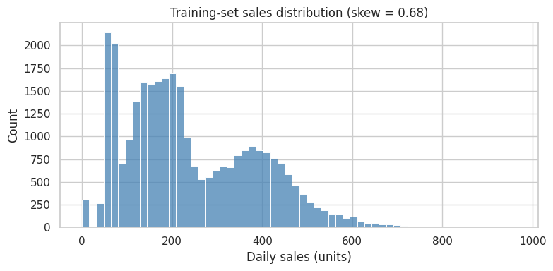
Figure 1. Distribution of daily sales in the training set.

2.2 Train/Test Split and Validation Strategy
Because the data is a time series and the objective is forecasting, the train/test split is chronological rather than random: the model was trained on data through early October 2023 (30,744 rows) and evaluated on a held-out final 90 days, October 3 – December 31, 2023 (1,620 rows), which the model never saw during training or tuning. This avoids leaking future information (e.g., through lag/rolling features) into the training set.
For hyperparameter tuning, TimeSeriesSplit (3 folds) was used in place of standard random K-Fold cross-validation, so that every validation fold falls chronologically after its training fold, consistent with how the model will actually be used in production.

2.3 Models Evaluated
- Naive seasonal baseline — predicts today's sales using the same weekday last week (7-day lag). Used as the bar any model must clear to justify its added complexity.
- Ridge Regression — a regularized linear model; interpretable, fast, and handles collinearity among the lag/rolling features. Hyperparameter tuned: alpha.
- Random Forest Regressor — a bagging ensemble of decision trees; captures nonlinear relationships and threshold effects (e.g., weather thresholds) without manual feature engineering. Hyperparameters tuned: n_estimators, max_depth, min_samples_leaf.
- Gradient Boosted Trees (HistGradientBoostingRegressor) — a boosting ensemble that sequentially corrects prior errors; typically strong on tabular data with engineered features. Hyperparameters tuned: max_iter, max_depth, learning_rate.

2.4 Evaluation Metrics
All models were scored on the held-out test set using three regression metrics:
- RMSE (root mean squared error) — the primary metric. Same units as sales; penalizes large misses more heavily, which matters most for inventory decisions.
- MAE (mean absolute error) — a secondary, more outlier-robust metric interpreted as typical forecast error in units.
- R² (coefficient of determination) — the share of variance in sales explained by the model; used as a normalized sanity check, not the ranking criterion on its own.

3. Findings

3.1 Model Comparison
All three tuned models beat the naive seasonal baseline by a wide margin, confirming that the weather, holiday, promotion, and calendar features carry real predictive signal beyond "assume this week looks like last week." The tuned Random Forest achieved the lowest test RMSE (25.29 units) and was selected as the final model; Gradient Boosting was a close second (25.77), and both tree ensembles clearly outperformed Ridge Regression, which as a linear model cannot capture the threshold-style weather effects observed in exploratory analysis (e.g., a sales jump only below freezing).
Model | RMSE (units) | MAE (units) | R² | Fit Time (s)
Random Forest (tuned) — SELECTED | 25.29 | 17.05 | 0.9667 | 97.7
Gradient Boosting (tuned) | 25.77 | 17.01 | 0.9654 | 10.5
Ridge Regression (tuned) | 35.41 | 23.83 | 0.9348 | 0.5
Naive seasonal (lag-7) baseline | 67.89 | 35.78 | 0.7602 | —
Table 1. Test-set performance of all models (held-out final 90 days).
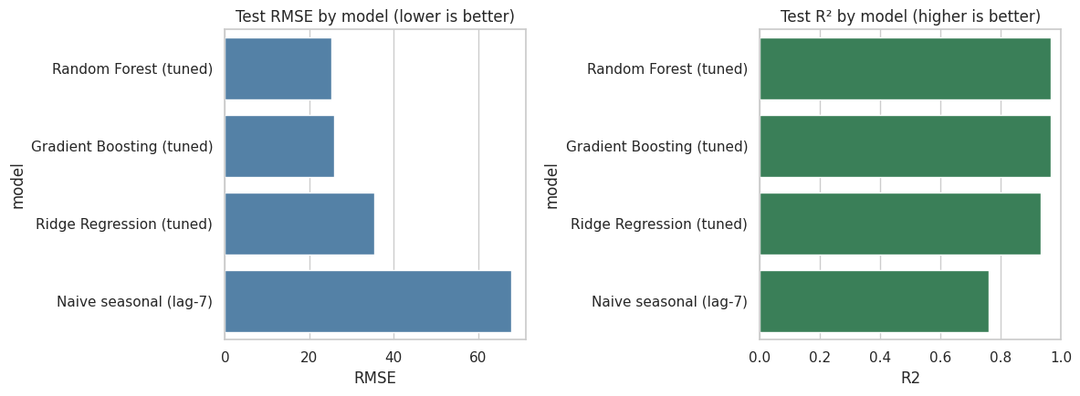
Figure 2. Test RMSE and R² by model.

3.2 Selected Final Model: Random Forest (tuned)
- Best hyperparameters: n_estimators = 150, max_depth = 12, min_samples_leaf = 1
- Test RMSE = 25.29 units (a 63% reduction versus the 67.89-unit baseline RMSE)
- Test MAE = 17.05 units — on average, the forecast is off by about 17 units of daily sales
- Test R² = 0.967 — the model explains roughly 97% of the variance in daily sales on unseen data
Diagnostic plots (Figure 3) show predictions tracking actual sales closely across the full range, including higher-volume days, with residuals scattered evenly around zero across the entire test period — no systematic drift or growing error over time, and no obvious pattern that would suggest the model is missing a major driver of demand.
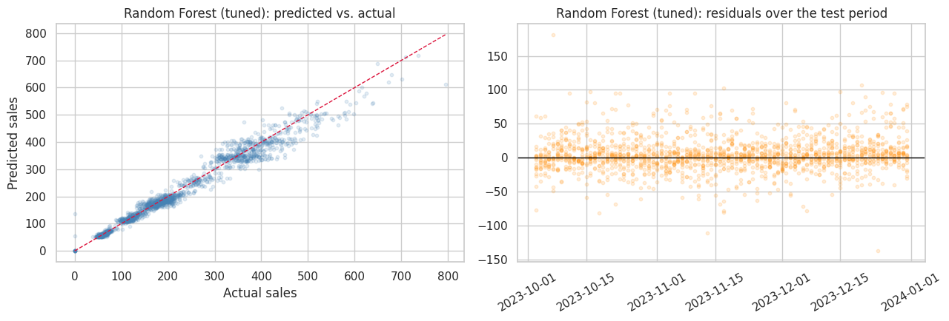
Figure 3. Random Forest: predicted vs. actual sales (left) and residuals over the test period (right).

3.3 What Drives the Forecast
Feature importance analysis on the final model (Figure 4) shows the forecast is driven overwhelmingly by a store/category's own recent demand:
- sales_roll_28 (28-day rolling average of sales) is by far the dominant driver, accounting for the large majority of the model's predictive power — recent baseline demand for a given store/category is the strongest signal of what tomorrow looks like.
- sales_lag_7 (same weekday last week) and on_promo (promotion flag) are the next most influential features, each contributing a modest but meaningful amount.
- stockout_flag and is_weekend follow, reflecting that stockout days depress sales, and weekends shift the level up or down depending on category.
- Weather variables (temp_f, precip_in), specific categories, and days_to_holiday contribute at the margins — they refine the forecast around the recent-history baseline rather than driving it outright.
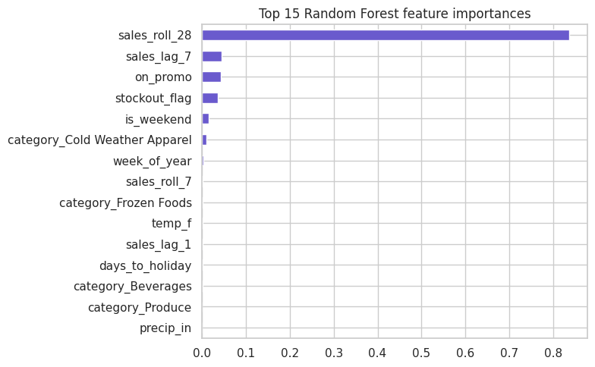
Figure 4. Top 15 Random Forest feature importances.
Practically, this means the model's accuracy depends heavily on having up-to-date recent sales history for each store/category at prediction time — it is much better suited to short-to-medium-horizon forecasting (days to a few weeks) than to long-horizon forecasting where recent history is unavailable or stale.

4. Recommendations
Based on these findings, we recommend the client consider the following three actions:
- Deploy the Random Forest model for short-to-medium-horizon inventory and labor planning.
With an RMSE of ~25 units and R² of 0.97 on unseen data, this model is accurate enough to replace the current “same as last week” heuristic for setting per-store, per-category order quantities and staffing levels roughly 1–14 days ahead, where recent sales history is available. Prioritize deployment for high-volume categories (Beverages, Produce) where the absolute unit error translates into the largest dollar impact.
- Use the promotion and weather signals to plan promotions and category-specific stocking, not just baseline demand.
Because on_promo and weather variables meaningfully move the forecast, the model can be used to size promotional lift ahead of a planned promotion, and to flag weather-sensitive categories (e.g., Cold Weather Apparel) for pre-positioning stock ahead of forecasted cold snaps, rather than reacting to weather after the fact.
- Establish a monitoring and retraining cadence rather than a one-time deployment.
Because the model leans heavily on recent rolling sales history (sales_roll_28), its accuracy will degrade if it is not refreshed with new data. We recommend retraining monthly (or after any material change in store mix, category mix, or promotion strategy), and tracking live RMSE/MAE against a held-out recent window to catch performance drift early.

5. Limitations and Ideas for Further Research
- Synthetic/simulated data caveat: this analysis was built on a structured synthetic sales dataset (5 years, 3 stores, 6 categories) designed to mimic realistic retail patterns (weekly/annual seasonality, promotions, stockouts, weather effects). Before production use, the same pipeline should be re-validated on the client's actual point-of-sale data, which may contain additional complexity (new store openings, assortment changes, supply disruptions) not represented here.
- Cold-start problem: because the model relies heavily on recent rolling sales (sales_roll_28), it cannot forecast well for brand-new stores, newly launched products, or categories with limited sales history. A separate cold-start approach (e.g., category/store-average priors) is recommended for these cases.
- Longer forecast horizons: current performance is strongest at short-to-medium horizons where recent lag/rolling features are fresh. Extending reliable accuracy further out (e.g., 30–90 days for seasonal buying decisions) would likely require a dedicated multi-step or recursive forecasting approach, or a model architecture built specifically for longer horizons.
- Prediction intervals, not just point forecasts: adding quantile/interval estimates (e.g., via quantile regression forests or conformal prediction) would let the client set safety-stock levels around the forecast rather than a single expected value, which is often more actionable for inventory decisions.
- Hierarchical/global modeling: the current model pools all store/category series together with dummy variables. Testing store- or category-specific models, or a hierarchical forecasting approach that reconciles store-level and total-chain forecasts, could improve accuracy for categories with distinct dynamics (e.g., highly seasonal Cold Weather Apparel).
- External demand drivers: incorporating local events, competitor promotions, and macroeconomic indicators (e.g., regional unemployment, gas prices) could further reduce residual error, particularly the occasional large outliers visible in the residual plot.
- Model interpretability tooling: adding SHAP value analysis on top of the feature-importance results here would let category planners see, for any individual forecast, exactly which factors pushed it up or down — useful for building trust in the model with store-level stakeholders.

